Task 12:

Write a Docker Compose file to define a multi-container application setup. This could involve defining services like databases, web servers, and other dependencies, and configuring their interconnections.

Step 1: Create An EC2 instance and install docker and docker compose in it.

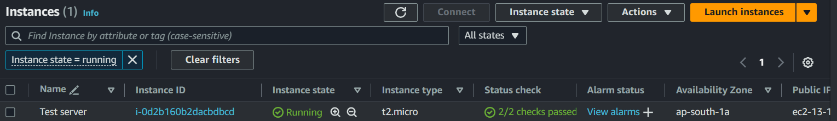

Step 2: Enter the Docker Compose script which consists services like DB, Web

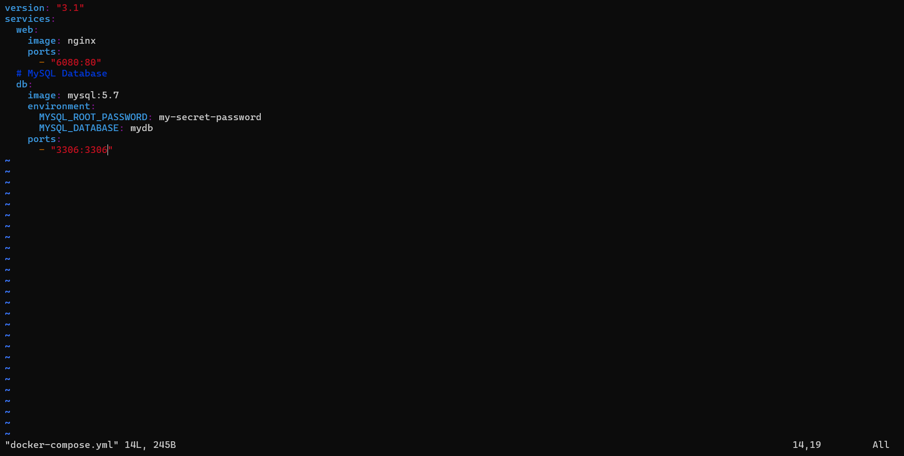

Step 3: Use “docker-compose up” command to execute the docker-compose script. Then use “docker ps” to check whether the containers are created or not.

